Partial Derivatives
Table of Contents
First Order Partial Derivates 2
Higher Order Partial Derivatives 4

First Order Partial Derivates
The rate of change of a function $f$ with respect to one of several independent variables is called the partial derivative.
If $z=f\left(x, y\right)$, then the first partial derivatives of $f$ with respect to $x$ and $y$ are the functions $f_{x}$ and $f_{y}$.
$$f_{x}\left(x, y\right)=\frac{δf}{δx}=\lim_{∆x→0}{\frac{f\left(x+∆x, y\right)-f\left(x, y\right)}{∆x}}$$
$$f_{y}\left(x, y\right)=\frac{δf}{δy}=\lim_{∆y→0}{\frac{f\left(x, y+∆y\right)-f\left(x, y\right)}{∆y}}$$
To find $f_{x}$, we consider a constant value of $y$ and differentiate with respect to $x$ and vice versa.
The value of the partial derivate at the point $\left(a, b\right)$ is denoted as ${\left.\frac{δz}{δx}\right|}_{\left(a, b\right)}$.

Geometrically, if $y=y_{0}$, then $z=f\left(x, y_{0}\right)$ is the curve intersecting the surface $z=f\left(x, y\right)$ and the plane $y=y_{0}$.
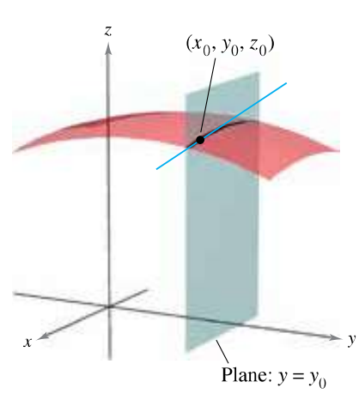
Thus, $\frac{δz}{δx}$ is the intersecting line. The exact value we get represents the slope of the surface along the $x$-axis at that point, like how $\frac{dy}{dx}$ represents the slope of the curve $y$ at $x$.

We can extend the concept into the fourth dimension, where $w=f\left(x, y, z\right)$, and even more. All we need to do to find the partial derivative with respect to a specific variable is set values for the other variables and then differentiate with respect to that variable.

Higher Order Partial Derivatives
The function $z=f\left(x, y\right)$ has the following second partial derivatives:
- $\frac{δ}{δx}\left(\frac{δf}{δx}\right)=\frac{δ^{2}f}{δx^{2}}=f_{xx}$
- $\frac{δ}{δy}\left(\frac{δf}{δy}\right)=\frac{δ^{2}f}{δy^{2}}=f_{yy}$
- $\frac{δ}{δy}\left(\frac{δf}{δx}\right)=\frac{δ^{2}f}{δyδx}=fxy$
- $\frac{δ}{δx}\left(\frac{δf}{δy}\right)=\frac{δ^{2}f}{δxδy}=f_{yx}$
The last two are called mixed partial derivatives.

